**WEEK-1**

1. **Suppose the cover price of a book is $24.95, but bookstores get a 40% discount. Shipping costs $3 for the first copy and 75 cents for each additional copy. What is the total wholesale cost for 60 copies?**

**Code-**

bookPrice = 24.95  
discount = .60  
shippingPriceRest = .75  
shippingPriceFirst = 3.00  
totalUnits = 60  
  
bookDiscountAmount = bookPrice * discount * totalUnits  
shipping = shippingPriceRest * 59 + shippingPriceFirst  
  
result = bookDiscountAmount + shipping  
  
  
print('The total price for 60 books including shipping and discount is: ')  
print('Total price of the books is: ' + str(bookDiscountAmount))  
print('Total Shipping is: ' + str(shipping))  
print('The Total price is: ' + str(result))

**Output-**

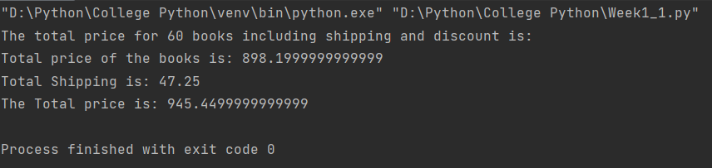

1. **Hourly workers typically earn overtime when they work more then 40 hours per week. For example, overtime pay might be 150% of the regular salary for the additional hours. Write a Python program that will ask the user for their hourly wage, then for the hours they have worked in the past week. With these two values print the wages earned for the week.**

**Code-**

hrs = input("Enter Hours:")  
h = float(hrs)  
rate = input("Enter the Rate:")  
r = float(rate)  
if h <= 40:  
 print( h * r)  
elif h > 40:  
 print(40* r + (h-40)*1.5 * r)

**Output-**

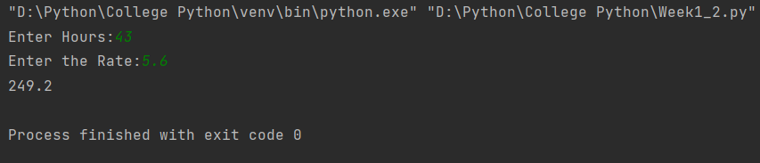

1. **Python provides a built-in function called len that returns the length of a string, so the value of len(&#39;allen&#39;) is 5. Write a function named right_justify that takes a string named s as a parameter and prints the string with enough leading spaces so that the last letter of the string is in column 70 of the display.**

**Code-**

def right_justify(s):  
 print((70 - len(s)) * " " + s)  
 return  
  
right_justify("allen")

**Output-**

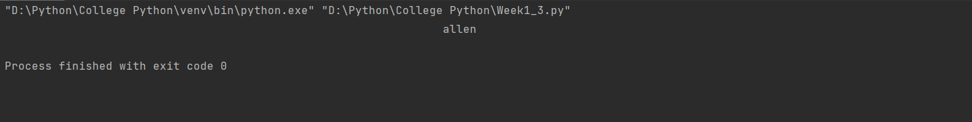

1. **Assume the variable named n holds a positive integer value. How do you determine the last digit of n? (Hint, what does the % operator do?)**

**Code-**

def lastDigit(n):  
 return (n % 10)  
  
n = int(input("Enter the number: "))  
print(lastDigit(n))

**Output-**

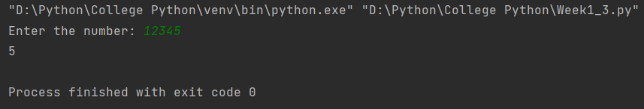

1. **Suppose any line of text can contain at most one url that starts with “http://” and ends at the next space in the line. Write a fragment of code to extract and print the full url if it is present. (Hint: read the documentation for find. It takes some extra arguments, so you can set a starting point from which it will search.)**

line = "The website is http://www.example.com and it has great content."  
start = line.find("http://")  
if start != -1:  
 end = line.find(" ", start)  
 if end != -1:  
 url = line[start:end]  
 print("The URL is:", url)  
else:  
 print("No URL found in the line.")

**Output-**

